INSURANCES POLICIES COMPARISON



VS



TERM LIFE INSURANCE VS WHOLE LIFE INSURANCE

* An OVERVIEW

Term life insurance offers more affordable coverage than whole life, but it only lasts for a certain number of years instead of your lifetime, and it doesn't have the tax-free savings component that whole life has.

Term and whole are two of the most common types of life insurance. Whole life is a form of permanent life insurance that lasts as long as you live (assuming you pay the policy’s premiums). It also includes a cash value account—a savings component that grows tax-free over time and that you can withdraw from or borrow against while you are alive.

Term life insurance, on the other hand, lasts only for a set period of time (the term) and does not accrue any cash value. We’ll break down the key features that distinguish these insurance mainstays.

KEY TAKEAWAYS

1. Term coverage only protects you for a limited number of years, while whole life provides lifelong protection—as long as you keep up with the premium payments.
2. Term life is just insurance, whereas whole life adds a cash value component that you can tap during your lifetime.
3. Whole life premiums can cost five to 15 times more than term policies with the same death benefit, so they're not a good fit for everyone.

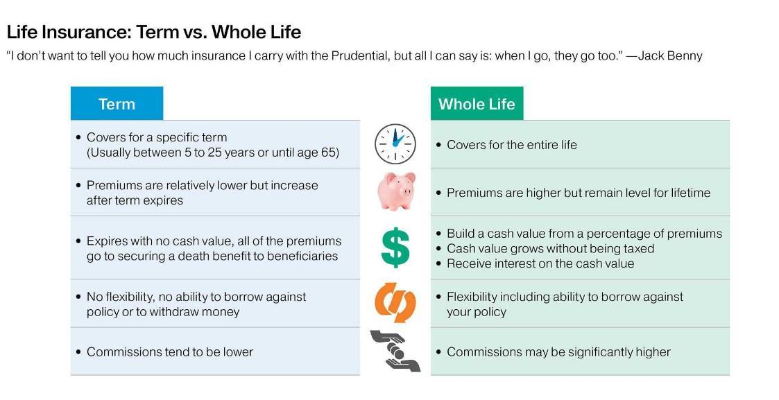

**TERM LIFE INSURANCE**

Term life insurance is perhaps the easiest to understand because it’s straightforward insurance, without a savings or investing component. The reason why you buy a term policy is because of the promise of a death benefit for your beneficiary should you pass away while it’s in force. For many people, it’s a way to make sure that their minor children are provided for and their mortgage is paid after they die.

**WHOLE LIFE INSURANCE**

Whole life insurance is a type of permanent insurance because it is designed to cover you from the time you purchase a policy, until you pass away. Whole life is a traditional form of life insurance that features a fixed premium rate and pays a fixed death benefit when you pass away. In addition, whole life insurance also features a cash value savings vehicle.

WHAT IS THSE DIFFERENCE BETWEEN TERM LIFE INSURANCE AND WHOLE LIFE INSURANCE

There are two significant differences between term vs. whole life insurance: the length that the policy is in effect and the cash value benefit.

1. Length of policy: With term life insurance, you’ll have a set time limit on your coverage. On the other hand, whole life insurance, which is known as permanent life insurance, remains in effect for your lifetime (as long as you pay your premiums).

2. Cash value benefit: Term life insurance premiums go toward the death benefit you will leave to your beneficiaries. But with whole life insurance, part of the premiums go toward the death benefit, while another portion goes into a cash value savings account that you’re able access while you are alive.

Let’s take a closer look at the features, advantages and disadvantages of each policy type, as well as a deeper dive into the difference between term and whole life insurance.

|  |  |  |
| --- | --- | --- |
| **Policy features** | **Pros** | **Cons** |
| **Cash value** | Borrow from or draw on the growing amount | Must be paid back or will be deducted from the death benefit |
| **Payment schedule** | Monthly, quarterly, semi-annually or annually | May be subject to additional fees for breaking up the payment throughout the year |
| **Value to beneficiary** | Face value paid to beneficiary regardless of age when you pass away (if over 18) | Any outstanding loan against the cash value could reduce the death benefit amount |
| **Dividends** | Could earn dividends based on company’s financial performance | Dividends are not guaranteed and are only available from certain companies |
| **Prequalifications** | May not require a medical exam | Coverage could be expensive depending on medical history |
| **Age limits** | Usually available to most adults up to age 80 | Seniors may not qualify for term and renewable options may be limited |
| **Premiums** | Typically, much cheaper than whole life for same death benefit | Health concerns could lead to higher premiums |
| **Decreasing term policies** | Can provide coverage for a mortgage | Premiums stay the same, but death benefit decreases |
| **Convertible and return-of-premium term policies** | Able to convert term to whole life or get a portion of premium returned after term expires | Whole life is more expensive than term life and uses current age when converting, return-of-premium is provided at higher costs |
| **Terms and medical requirements** | Terms typically range from five to 30 years and usually involve medical questions, but possibly a medical exam may be skippable | Optional renewable term feature can be expensive, health history may require a medical exam |

**Term life insurance:**

Term life insurance can be purchased for a set amount of time, such as 30 years. After this period, your coverage will end, unless the policy is renewable or convertible. If it is, insurers typically require you to trigger those options several months before your term ends (if the policy doesn’t renew automatically). Keep in mind that policies that are renewed generally happen at a new rate. When comparing term vs. whole life insurance, term coverage is generally less expensive.

Consider the following factors that affect term life insurance.

**Terms:** Term Life Insurance often pays a set face value and covers you for a specific period, typically ranging between five and 30 years. The 20-year term policy is the most common, according to the Insurance information Institute.

**Medical requirements:** To get a term life policy, you may have to answer health questions or take a medical exam. Some policies feature a renewable option which allows you to renew the policy for another term on an annual basis, oftentimes without taking another medical exam, but the rate will be based on your current age.

**Convertible and return-of-premium term policies:** Some term life policies are convertible, allowing you to convert them to a permanent policy after a certain period without taking another medical exam. A policy with a return of premium back pays back a portion of the money you paid after the term ends, but this benefit comes with much higher premiums

**Age limits:** Many term life policies have an age limit, usually around 80. So, if you want to renew a 20-year policy at age 65, the insurer might only offer you a 15-year term to continue coverage.

**Premiums:** Term life insurance companies base your premium on a few factors, including your age, health at the time of application or renewal and life expectancy. Term life insurance is much more affordable for people at a younger age and in good health than whole life. However, it’s common for term policy premiums to increase as you age.

**Term vs. whole life insurance**

Whole life and term life policies have one major thing in common — they both pay a death benefit when you pass away. So, for example, if you have a $100,000 term life policy and you pass away during the term, your beneficiary will receive $100,000.

|  |  |
| --- | --- |
| Likewise, if you purchase a $100,000 whole life policy and continue to pay the premium until you die, that policy will pay $100,000. With both term life and whole life, the death benefit is typically distributed tax-free and can be used for any purpose. **Why choose term life insurance** | **Why choose whole life insurance** |
| Usually has cheaper premiums | Cash value and potential for dividends |
| Good health history could waive medical exam | Medical exam isn’t always required |
| Can typically purchase much higher death benefit amounts | Option to ta |

**Whole life insurance**

Whole life insurance is a type of permanent insurance because it is designed to cover you from the time you purchase a policy, until you pass away. Whole life is a traditional form of life insurance that features a fixed premium rate and pays a fixed death benefit when you pass away. In addition, whole life insurance also features a cash value savings vehicle.

Here are some important things to know about whole life policies:

**Dividends:** If you buy whole life insurance from a mutual company, you might be eligible to receive dividends, based on the company’s financial performance. Reinvesting these dividends can help your cash value grow more quickly.

**Prequalification:** Depending on the policy, you may be expected to provide your medical history via a health questionnaire or take a medical exam.

**Pricing:** Whole life insurance is generally more expensive when compared to term life because the policy covers you for as long as you live and includes cash value benefits.

**Cash Value:** Part of your premiums are set aside in a savings account, known as cash value. You have the option to withdraw or borrow the cash value while you are still living, and use the money for any purpose. However, the cash value is usually only accessible while you are alive and will not be included in your death benefit.

**Value to beneficiary:** When the insured passes away, their designated beneficiary receives the entire face value (also called the death benefit), less any outstanding loan taken from the cash value. As noted above, any remaining cash value is typically not included in the death benefit.

**Payment schedules:** Most insurers give the option to pay a whole life premium monthly, quarterly, semi-annually or annually. These types of policies cover you as long as you continue to pay the premium

THANK YOU

BY

T. Uma Maheswari

BBA

ANDRA UNIVERSITY